Draw the activity diagram for the specified Case Study.
Table of Contents

1.) Case Study: 2
1.1) Introduction 2
1.2) The Challenge 2
2.) The Solution: Expense Analyzer App 3
2.1) Voice Recognition: 3
2.2) Geographical Limit Enforcement: 3
2.3) Financial Goal Fulfilment: 3
3.) ACTIVITY DIAGRAM 4
4.) Use case Diagram 6
4.1) Create Account Successfully 6
5.) Results and Benefits 7
4.1) Effortless Expense Tracking: 7
4.2) Improved Financial Awareness: 7
4.3) Promotion of Responsible Spending: 7
4.4) Savings and Goal Attainment: 7
6.) Real-World Applications 8
5.1) Individual Financial Management: 8
5.2) Family Budgeting: 8
5.3) Business Expenses: 8
7.) Conclusion 9

Creating a case study for your Expense Analyzer App can help illustrate its real-world applications and benefits. Here's a sample case study:

- Case Study:
- Optimizing Personal Finance with the Expense Analyzer App

Introduction
In today's fast-paced world, managing personal finances has become increasingly challenging. Budgeting, tracking expenses, and adhering to financial goals can be cumbersome and prone to errors. Anmol Goyal, a forward-thinking MCA student, recognized these challenges and embarked on a journey to simplify personal finance management. He developed the Expense Analyzer App, a groundbreaking solution that leverages voice recognition and geographical limit enforcement to revolutionize the way individuals manage their expenses.

The Challenge
Traditional expense tracking methods often require manual data entry, which can be time-consuming and error-prone. Additionally, many individuals struggle to stay within their budget limits, leading to overspending and financial stress. Anmol Goyal aimed to address these challenges and create a user-friendly tool that would empower individuals to take control of their finances.

The Solution: Expense Analyzer App
Anmol's innovative solution, the Expense Analyzer App, combines cutting-edge technology with user-centric design principles. The app offers the following key features:

2.1) Voice Recognition: Users can effortlessly input expenses by simply speaking them, eliminating the need for manual data entry. This hands-free approach enhances user convenience and reduces errors.

2.2) Geographical Limit Enforcement: The app utilizes GPS tracking to monitor users' expenses within predefined geographic areas. When expenses exceed set limits in a specific zone, the app sends immediate alerts, promoting responsible spending.

2.3) Financial Goal Fulfilment: When expenses fall below allocated limits, the app suggests optimal budget allocations to fulfill unmet financial needs or savings objectives, making financial planning accessible and actionable.

3.) ACTIVITY DIAGRAM

3.1.) For User Registration
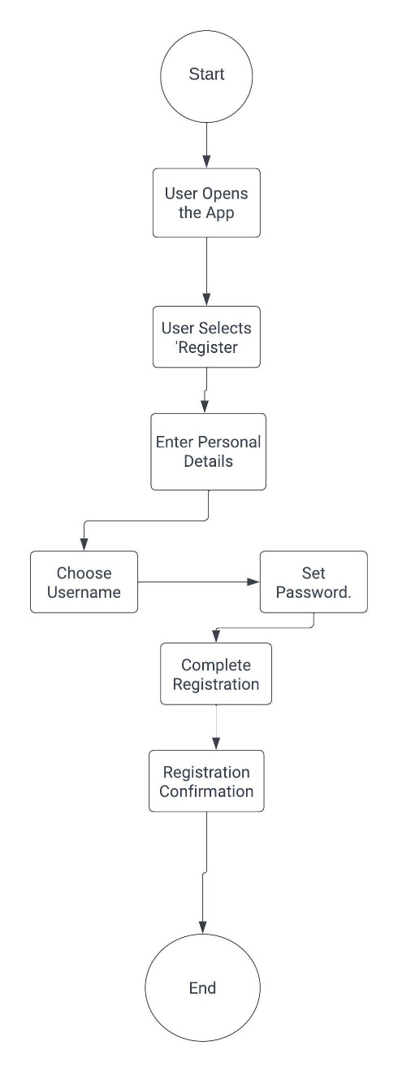

Figure 1 Activity Diagram for User Registration

3.2.) Mode Selection
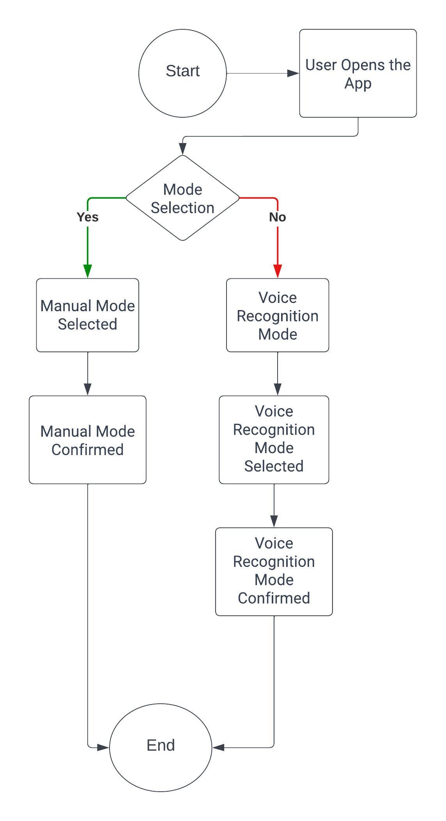
Figure 2 Mode Selection after Opening App

Use case Diagram

4.1) Create Account Successfully
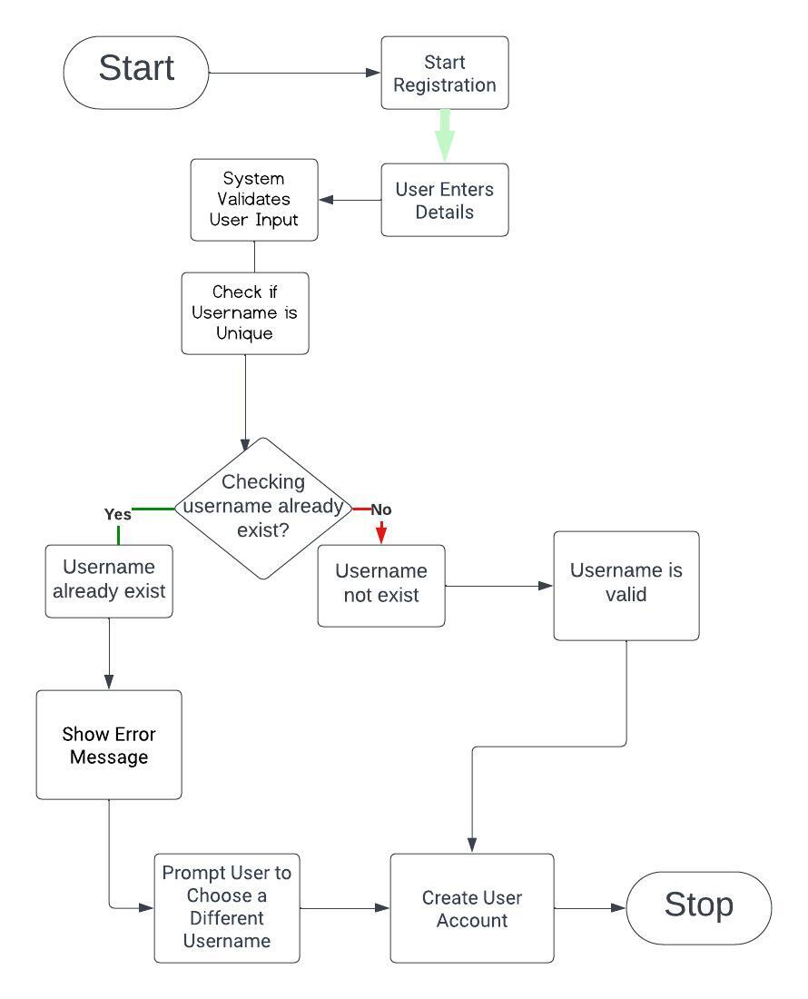
Figure 3 Created Account Sucesfully

Results and Benefits
The Expense Analyzer App has yielded significant results and benefits for users:

4.1) Effortless Expense Tracking: Users can track their expenses effortlessly, thanks to voice recognition technology, saving time and reducing the burden of manual data entry.

4.2) Improved Financial Awareness: The app provides users with insights into their spending habits within different geographical areas, enhancing their understanding of their financial behavior.

4.3) Promotion of Responsible Spending: Geographical limit enforcement alerts users when they exceed spending limits, encouraging responsible financial behavior and reducing overspending.

4.4) Savings and Goal Attainment: The app empowers users to achieve their financial goals by suggesting optimal budget allocations when expenses are below set limits.

Real-World Applications
The Expense Analyzer App has found applications in various real-world scenarios:

5.1) Individual Financial Management: Individuals use the app to gain control over their personal finances, reduce overspending, and achieve their savings goals.

5.2) Family Budgeting: Families benefit from the app by setting spending limits for various family members and tracking expenses within defined geographic areas.

5.3) Business Expenses: Small businesses use the app to monitor and control employee expenses during business trips or within specific regions.

Conclusion
Anmol Goyal's Expense Analyzer App represents a significant leap forward in personal finance management. Its combination of voice recognition and geographical limit enforcement offers a unique and user-friendly solution to the challenges of budgeting and expense tracking. As individuals and businesses seek more efficient ways to manage their finances, the Expense Analyzer App is poised to make a lasting impact, promoting responsible spending and financial well-being.

Feel free to customize this case study to include specific details and outcomes related to your Expense Analyzer App.

